26th National Cursillo® Encounter
Lewis University, Romeoville, IL
Frequently Asked Questions

What is the date of the Encounter?  Thursday, August 4 – Sunday, August 7, 2016.  Where is the Encounter being held?  Lewis University, One University Parkway Romeoville, IL 60446  What is the Encounter registration fee?  - $345.00 per person if the Encounter Registration Form is received by June 15, 2016.  - Registration fee increases to $400.00 per person on June 16, 2016.  - Unable to guarantee attendance after June 30, 2016. | 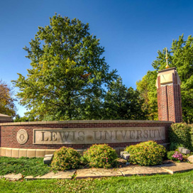
Can the Encounter registration fee be paid in payments?
No, full payment per person must accompany the Encounter Registration Form.

How do I register for the Encounter?
You may register on-line at https://www.natl-cursillo.org/encounter/ or download a registration form and mail form with full payment to the National Cursillo® Center, P.O. Box 799, Jarrell, TX 76537. You can also fax form to 512-746-2030, or e-mail form to admin@natl-cursillo.org . Use a separate Encounter Registration Form for each person.

There is a $40.00 non-refundable fee for all cancellations up until May 31, 2016. No refunds after May 31, 2016 – No exceptions! The National Cursillo® Center is responsible for payment to Lewis University regardless of cancellations.

How do I pay for Encounter registration fee?
Payment can be made with Visa or MasterCard credit cards only or personal check. Make checks payable to National Cursillo® Center and mail to National Cursillo® Center, P.O. Box 799, Jarrell, Texas 76537. Lay Directors can also redeem vouchers received from the $3/yr donation campaign to pay for the Encounter registration fee.

Do I need to bring bed linens, etc?
The University will provide bed linens, blanket, towel, and pillow.
 | What time is check-in?  Check-in is from 2:00 p.m. – 8:00 p.m on Thursday August 4.  What time does the Encounter begin?  Dinner will be served from  5:00 p.m. – 7:00 p.m.  Opening of the 26th National Cursillo Encounter will begin at 7:30 p.m. in the Field House.
  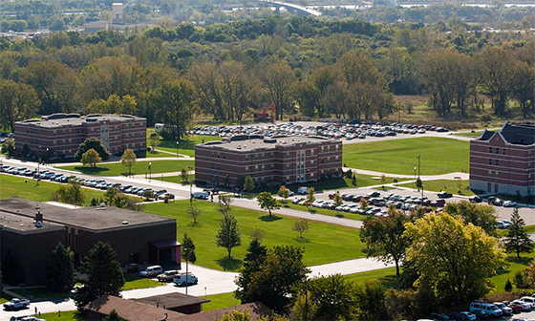
What time is check-out?
Cursillistas must check-out by 10:00 a.m. on Sunday, August 7, 2016.

What airport will I be flying into?
Lewis University is 30 minutes from O’Hare International Airport (ORD). Complimentary transportation from/to O’Hare International Airport will be provided on Thursday August 4 and Sunday August 7, 2016.

What does registration fee include?
The registration fee includes three nights lodging, dinner on Thursday evening, 3 meals on Friday and Saturday, and breakfast on Sunday morning.

NOTE: Participants are responsible for their own lunch on Thursday. Lunch is not included in the registration fee.

Where can I get a campus map and driving directions to Lewis University?
See this link below:
http://www.lewisu.edu/visitors/index.htm

What is the lodging capacity and set-up for the Encounter?
700 persons. Two persons per bedroom.

Where can I send Palanca for the Encounter?
E-mail palanca letters to: blinek29@gmail.com

